# Design Document

# 1.2 Tag Line

A 2D pirate adventure game for GameBoy Color. Take on the role of Captain as you lead your scallywags in search of the Gilden Egg.

# 1.3 Team

* Riley Knybel

# 1.4 Update Log

* 10/26 – Document created
* 10/27 – Update to match assignment 4 game design doc template

2. Game Overview

# 2.1 Game concept

# World Map

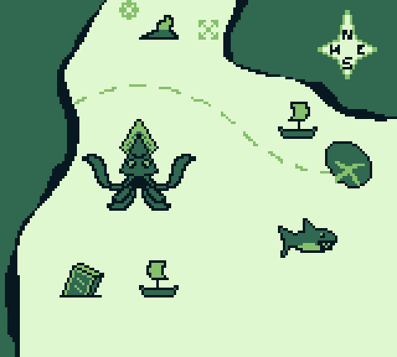

# Game Scenes

Title Screen

Ship deck

Below ship deck

Map screen

Other ship deck for fights

Other ship in distance for cannonball fight

Davey Jones’s Locker (Game over)

3. Gameplay

4. Mechanics

Note that sprites are developed in original GameBoy palette, and colors are changed within the GameBoy Color engine.

**Weapons**

Cutlass

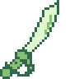

When equipped, press B to swing at the tiles directly in front of the player.

Bomb



When equipped, press B to throw and damage a 3x3 tile area next to the player. The player can carry 3 bombs at once.

Flintlock

[image]

When equipped, press B to damage up to 5 tiles away from the player in a straight line.

**Captain**

The captain is the player character.

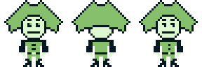

Variables:

xPosition

yPosition

hasCutlass

hasBomb

hasFlintlock

cutlassOut (enemies take damage when true)

**Parrot**



Tells you where to go on the map screen

The parrot avatar image will appear for its dialogue

**Scallywag**

These are the captain’s friendly underling pirates. NPCs.

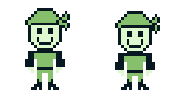

They bounce up and down, naively eager to go on an adventure.

Display silly dialog when player interacts by pressing A.

**Baddies**

Pirates from another ship that are out for blood.

**Anti-captain**

Captain of another ship, kind of like a boss

**Kraken**

Big squid boss enemy

**Ship Wheel**

Interact with the wheel using the A button to view the map screen

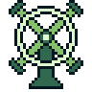

5. Story and Narrative

6. Game World

7. Characters

8. Levels

**Level List**

1 – Set sail!

**2 – wind blows you into the kraken**

3 – attack kraken combat scene

4 – throw food/flee into another ship that hits u with a cannonball

5 – turn around and die (Davey Jones’ Locker)

7 – fight other ship combat scene

6 – storm after fighting kraken

8- go north into icy ocean

9 go south into sharks

10-get lost at sea because the sharks turned you around



11-second ship fight scene

12-got secret map

13-get the gilden egg

**Twine Layout:**

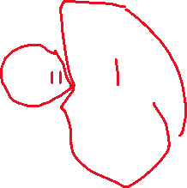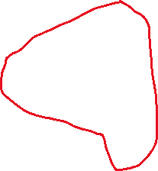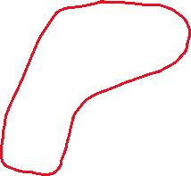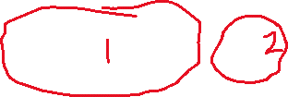

# Systems/UI Elements

Grog meter:

keeps track of your food supply. Player must make good, if risky, decisions to make sure they don’t run out of grog



The health variable stores the health left (maximum 8) and the grog meter displays that value using tankards.

When health hits 0, the game over scene loads.

Map: controls the decision tree for the player. New paths are unlocked after each event/scene. Player chooses a cardinal direction with the D-pad to make a decision.

9. Interface

Movement (ship deck scenes):

The player can navigate the floor area of the scene in 4 directions. Collisions prevent the player from walking over barriers, objects or NPCs. Objects and NPCs can be interacted with by pressing A. If a weapon is equipped, pressing B will activate the weapon.

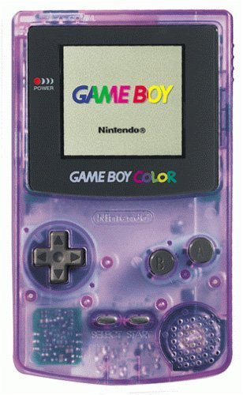

Use weapon/exit dialog

Up/down/left/right

Movement around scene

Interact/progress dialog

Map

The map is where the player decides the next area to sail to after an event is finished. The parrot tells the player about next steps, and a menu is displayed to choose where to go. The player’s current location is displayed by a ship with a point above it.

Up/down

Choose action

Progress dialog/pick action

Back to last scene

# Sound FX and music:

Intro song

Danger song (low on grog)

Got treasure song

Sailing song

Got grog song